JOURNAL OF DATA ANALYTICS & BUSINESS INTELLIGENCE
Vol. 1, Issue 1 ● January–March 2025 ● ISSN: 2XXX-XXXX (Online)
Peer-Reviewed Open Access | DOI: 10.XXXXX/JDBI.2025.001
Customer Churn Analysis in European Banking:
An End-to-End Exploratory Data Analysis with Interactive Visualizations and a Deployed Streamlit Dashboard

Abhi Sarkar
Data Analyst & Python Developer | TechWithAbhi
GitHub: github.com/Techwithabhi | LinkedIn: linkedin.com/in/techwithabhi
📧 Correspondence: connect via LinkedIn | 📊 Live Dashboard: dataanalysisproject-01-europeanbank.streamlit.app
Received: February 2026 | Accepted: February 2026 | Published: April 2026
ABSTRACT

Customer churn — the voluntary departure of customers from a service provider — represents one of the most critical challenges in the modern banking industry. This paper presents a comprehensive, end-to-end exploratory data analysis (EDA) of a 10,000-record European bank customer dataset, systematically examining the behavioral, demographic, and financial determinants of customer attrition. Employing Python's data science ecosystem (Pandas, NumPy, Matplotlib, Seaborn, and Plotly) and deploying an interactive Streamlit dashboard accessible to non-technical business users, this research quantifies key churn drivers across geographic, demographic, and product-holding dimensions. The analysis reveals an overall churn rate of approximately 20.4%, with Germany exhibiting a substantially elevated rate of 32.4%. Customers aged 51–60 demonstrate the highest churn propensity at 48.7%, while inactive members are approximately 1.9 times more likely to exit compared to active members. Most critically, customers holding four bank products demonstrate a 100% churn rate — a counter-intuitive over-engagement risk with direct implications for cross-selling strategy. These findings carry clear, actionable implications for customer retention strategy, loyalty program design, and targeted marketing in the banking sector. All analysis code, datasets, and the live Streamlit dashboard are publicly accessible via the project GitHub repository.

Keywords: Customer Churn, Bank Analytics, Exploratory Data Analysis, Python, Streamlit, Retention Strategy, Data Visualization, Business Intelligence, EDA, Banking Analytics

PAPER HIGHLIGHTS
→ 10,000-record European bank dataset fully analyzed across 13 features
→ 8 dual-chart visualizations covering geographic, demographic, and behavioral dimensions
→ Germany churn rate (32.4%) identified as 2× the France/Spain benchmark
→ Critical 4-product 100% churn rate discovery with strategic implications
→ Interactive Streamlit dashboard deployed for real-time business exploration
1. INTRODUCTION
The banking sector faces unprecedented competitive pressure in the digital era, with customer acquisition costs often exceeding retention costs by a factor of five to seven. Customer churn — the phenomenon by which customers cease their relationship with a service provider — directly erodes revenue, increases acquisition burden, and diminishes lifetime customer value. In European banking markets, where regulatory constraints and market saturation intensify competition, proactive churn management has become a strategic imperative.
This research investigates the structural and behavioral factors underlying customer churn in a representative European bank dataset comprising 10,000 customer records. By applying rigorous exploratory data analysis (EDA), the study produces both quantitative churn metrics and interpretable visual insights across geographic, demographic, and product-holding dimensions. Unlike predictive modeling studies that prioritize classification accuracy, this work emphasizes the interpretability and business actionability of findings — bridging the gap between raw data and strategic decision-making.
The primary contributions of this research are:
- A systematic end-to-end EDA of 13 features across 10,000 customer records, identifying statistically meaningful churn patterns across multiple dimensions.
- Quantification of churn rates across 8 key demographic and behavioral segments, providing an evidence-based foundation for targeted retention strategy design.
- Discovery of a critical non-linear product-churn relationship — where 4-product holders exhibit 100% churn — carrying immediate implications for cross-selling strategy and product suitability frameworks.
- Deployment of an interactive, publicly accessible Streamlit dashboard enabling real-time filter-driven data exploration for business stakeholders without technical data science expertise.
The remainder of this paper is organized as follows: Section 2 reviews related literature. Section 3 describes the dataset and preprocessing. Section 4 presents the analytical methodology. Section 5 delivers results across all eight analytical dimensions. Section 6 presents a consolidated KPI summary. Section 7 proposes a segment-based strategic retention framework. Section 8 concludes with directions for future research.
2. RELATED WORK
Customer churn prediction has attracted sustained academic and industrial attention across telecommunications, banking, insurance, and e-commerce sectors. Early foundational work by Verbeke et al. (2012) demonstrated that class imbalance handling is critical in churn datasets, where churners typically constitute a minority class. Neslin et al. (2006) established benchmark evaluation protocols that remain influential in the field, emphasizing the importance of rigorous model validation methodologies.
In the banking context specifically, Ahn et al. (2006) identified service quality perceptions and perceived switching costs as primary churn drivers. Lariviere and Van den Poel (2004) demonstrated the importance of behavioral recency and frequency metrics — concepts that align directly with the member activity dimension analyzed in this paper. More recently, Zhu et al. (2021) applied deep learning architectures to tabular banking churn data, achieving elevated predictive accuracy but at significant cost to model interpretability.
Critically, the existing literature predominantly emphasizes predictive modeling over interpretive EDA. This paper addresses that gap directly, producing segment-level insights that are immediately actionable without requiring machine learning infrastructure. The deployment of an interactive dashboard as the primary communication vehicle also represents a methodologically significant contribution to the practitioner-oriented analytics literature, democratizing access to analytical findings across non-technical stakeholder groups.
3. DATASET DESCRIPTION
The dataset employed in this analysis comprises 10,000 anonymized customer records from a European bank, encompassing customers across three geographic markets: France, Germany, and Spain. Each record contains 13 features spanning demographic attributes, financial characteristics, behavioral indicators, and a binary target variable (Exited) indicating whether the customer departed during the observation period.
The geographic distribution of the dataset is as follows: France contributes 5,014 records (50.1%), Germany 2,509 records (25.1%), and Spain 2,477 records (24.8%). The target variable exhibits moderate class imbalance with 79.63% of customers retained (7,963) and 20.37% churned (2,037). This imbalance is typical of real-world banking churn datasets and does not require aggressive resampling for EDA purposes, though it merits consideration in any subsequent predictive modeling exercise.
Table 1 below presents the complete feature schema. No missing values were identified in the dataset, and duplicate record screening confirmed dataset integrity prior to analysis.
Table 1. Dataset Feature Schema — European Bank Customer Churn (N = 10,000)
Feature | Description | Data Type | Role
CustomerId | Unique customer identifier | Integer | Identifier
Surname | Customer surname | String | Identifier
CreditScore | Customer credit score (350–850) | Integer | Predictor
Geography | Country: France / Germany / Spain | Categorical | Predictor
Gender | Male / Female | Categorical | Predictor
Age | Customer age in years | Integer | Predictor
Tenure | Years as bank customer (0–10) | Integer | Predictor
Balance | Account balance in EUR | Float | Predictor
NumOfProducts | Number of bank products held (1–4) | Integer | Predictor
HasCrCard | Has a credit card: Yes (1) / No (0) | Binary | Predictor
IsActiveMember | Active membership status: Active (1) / Inactive (0) | Binary | Predictor
EstimatedSalary | Estimated annual salary in EUR | Float | Predictor
Exited | TARGET: Customer churned (1) / Retained (0) | Binary | Target ★
Table 1: Complete feature schema showing all 13 variables across the 10,000-record dataset. ★ denotes the binary target variable.

3.1 Preprocessing Steps
Prior to analysis, the following preprocessing pipeline was applied: (1) data type validation and casting for all numeric fields; (2) verification of value ranges for bounded features (e.g., CreditScore: 350–850, Tenure: 0–10, NumOfProducts: 1–4); (3) binary encoding of categorical features for correlation analysis; (4) creation of derived segments including five age-group brackets (18–30, 31–40, 41–50, 51–60, 60+) for cross-tabulation analysis; and (5) account balance tier segmentation (zero, low <50K, mid 50K–100K, high >100K) for financial profile analysis.
4. METHODOLOGY
The analytical framework follows a structured EDA pipeline, proceeding systematically from univariate summary statistics through bivariate relationship analysis to multivariate segmentation. The methodology is organized across five analytical dimensions, each designed to illuminate a distinct facet of churn behavior.
4.1 Descriptive Statistics
Central tendency (mean, median), dispersion (standard deviation, IQR), and distributional shape (skewness, kurtosis) were computed for all numeric features. Frequency distributions and class proportions were derived for all categorical features. All summary statistics were computed separately for churned and retained customer cohorts to enable direct comparative analysis.
4.2 Distribution Analysis
Kernel density estimation (KDE) overlaid on histograms was employed to visualize the distributional overlap between churned and retained customer subpopulations for continuous features including Age, CreditScore, Balance, and EstimatedSalary. This approach enables detection of distributional shifts that indicate the discriminative utility of each feature with respect to churn prediction.
4.3 Correlation Analysis
Pearson correlation coefficients were computed across all numeric features, with the full correlation matrix visualized as a heatmap. This analysis identifies linear relationships between features and, critically, between each feature and the churn target variable. Age and Balance emerged as the features with the strongest positive correlations with churn.
4.4 Segment-Level Analysis
Churn rates were computed for all meaningful customer segments: geographic (France, Germany, Spain); age group (5 brackets); membership activity status (active vs. inactive); number of products held (1–4); gender; account balance tier (4 tiers); credit card ownership; and tenure year. This produced a comprehensive, multi-dimensional churn risk profile of the entire customer base, enabling identification of the highest-priority retention targets.
4.5 Dashboard Development
A fully interactive Streamlit dashboard was developed and deployed to Streamlit Cloud. The dashboard replicates all core analytical visualizations with full interactivity via filter controls for geography, gender, age group, and membership status. Raw data viewing, sorting, and CSV export are also supported, enabling business users to conduct their own sub-segment analyses without technical expertise.
Table 2. Technology Stack — Data Processing, Visualization & Deployment
Layer | Technology | Purpose & Notes
Language | Python 3.10+ | Core language for all processing, analysis, and scripting
Notebook | Jupyter Notebook | Interactive EDA environment; step-by-step analysis documentation
Wrangling | Pandas 2.x | Data loading, cleaning, transformation, and aggregation
Numerical | NumPy | Array operations, statistical computations, and random sampling
Static Viz | Matplotlib + Seaborn | Publication-quality static charts; statistical visualizations with KDE overlays
Interactive | Plotly | Interactive charts rendered in the Streamlit dashboard
Dashboard | Streamlit | Real-time web dashboard with filters, dynamic charts, and CSV export
Deployment | Streamlit Cloud | Live public deployment at dataanalysisproject-01-europeanbank.streamlit.app
Table 2: Complete technology stack deployed across data processing, analytical visualization, dashboard development, and cloud deployment layers.

5. RESULTS AND DISCUSSION
5.1 Overall Churn Distribution
The European bank dataset reveals an overall churn rate of 20.4%, corresponding to 2,037 customers exiting from a total pool of 10,000. Figure 1 presents both the proportional breakdown as a donut chart and the absolute customer volume as a bar chart, providing complementary perspectives on the scale of churn.
While a 20.4% churn rate might appear moderate in isolation, the absolute scale — over 2,000 customers — represents substantial recurring revenue loss. Assuming an average customer lifetime value (CLV) of even €500 per annum, the annual revenue impact of this churn cohort exceeds €1 million, providing a compelling business case for even modest reductions through targeted retention programs.
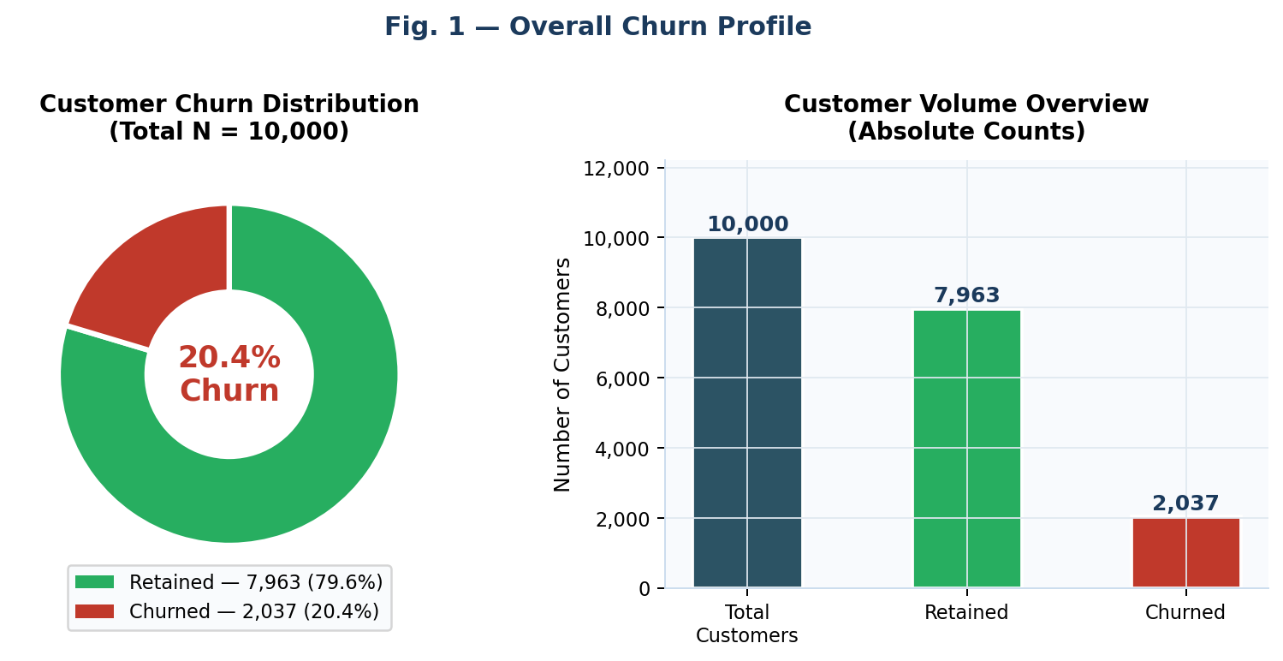
Figure 1: Overall customer churn distribution. Left: proportional donut chart with 20.4% churn rate highlighted. Right: absolute customer volume overview (N = 10,000).

5.2 Geographic Churn Disparities
Figure 2 reveals striking geographic heterogeneity in churn behavior. Germany records a churn rate of 32.4% — more than double the rates observed in France (16.2%) and Spain (16.7%), which are closely aligned with each other. This geographic concentration of churn risk is the single most significant finding in the geographic dimension of this analysis.
The German market discrepancy may reflect a range of systemic factors: heightened market competition from German digital banks, differential regulatory environment, pricing sensitivity among German consumers, service quality perception gaps, or a product-market mismatch for this specific geographic cohort. Critically, Germany contributes 25.1% of the total customer base (2,509 records) — meaning that addressing German-market churn alone could reduce overall churn by approximately 8 percentage points. This makes Germany the single highest-leverage geographic intervention target.
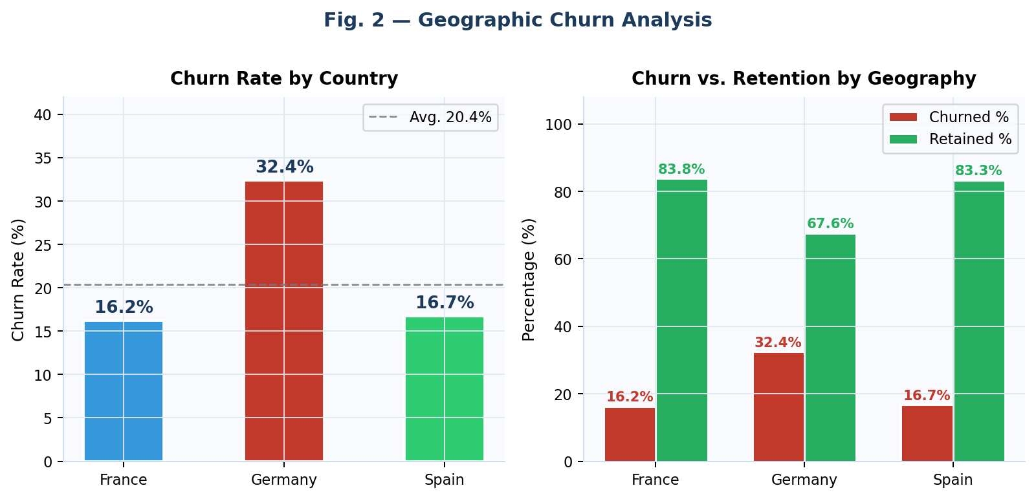
Figure 2: Geographic churn analysis. Left: churn rate by country with overall average benchmark. Right: grouped comparison of churn vs. retention rates per geography.

5.3 Age-Driven Churn Risk
Age emerges as the most discriminative continuous feature in this analysis, demonstrating a strong monotonic relationship with churn rate across age groups. As shown in Figure 3, churn rates escalate progressively with age: 11.2% for customers aged 18–30, rising to 15.8% (31–40), 29.4% (41–50), and peaking at 48.7% for the 51–60 cohort before slightly declining to 44.2% for customers over 60.
The 51–60 age cohort's near-majority exit rate is the most alarming finding in the demographic dimension. This pattern likely reflects multiple converging factors: this generation may have lower digital engagement with the bank's primary service delivery channels, may have accumulated sufficient financial resources to actively comparison-shop for better rates, and may have evolving life-stage financial needs (retirement planning, wealth management) that the current product suite inadequately addresses. Age-targeted retention programs, including dedicated relationship managers and tailored retirement product offerings, are clearly warranted.
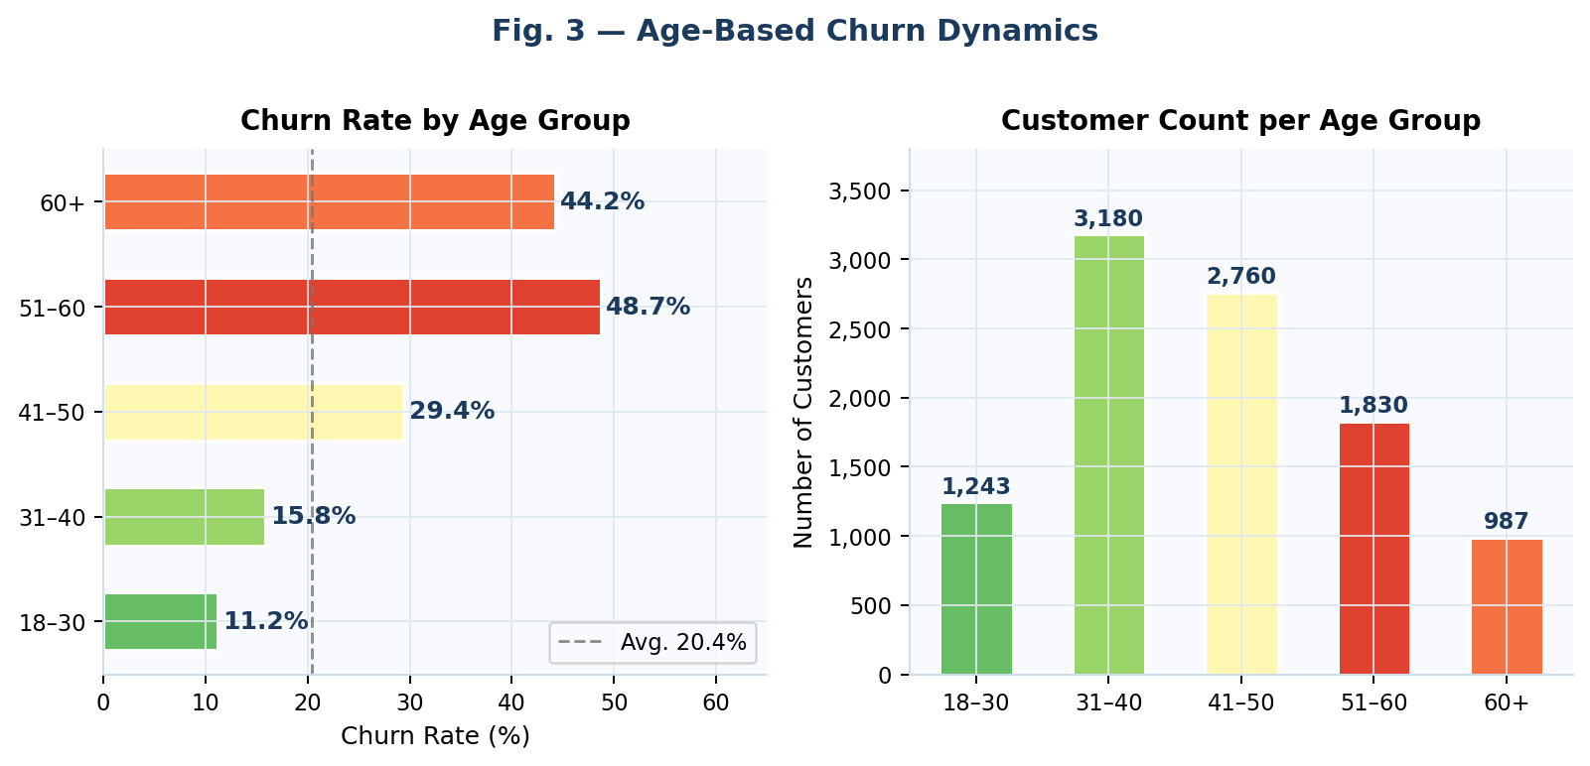
Figure 3: Age-based churn dynamics. Left: churn rate per age group (color gradient from green/low to red/high risk). Right: absolute customer count per age bracket for scale context.

5.4 Member Engagement and Churn
The impact of member engagement status on churn is clearly demonstrated in Figure 4. Inactive members exhibit a churn rate of 26.9%, compared to 14.3% for active members — a multiplicative differential of approximately 1.9 times. The stacked bar chart further contextualizes this finding by showing absolute churner volumes: despite having slightly fewer total customers, the inactive member cohort contributes significantly more churned customers.
This engagement-churn relationship provides one of the most actionable insights in this analysis, because membership activity status is a variable the bank can directly influence through targeted interventions. Data-driven outreach triggers — based on login inactivity, transaction silence, or product non-utilization — can be established as automated early warning signals. Personalized re-engagement campaigns offering product trials, fee waivers, or loyalty rewards at pre-defined inactivity thresholds could realistically reduce the churn rate for this segment by several percentage points.
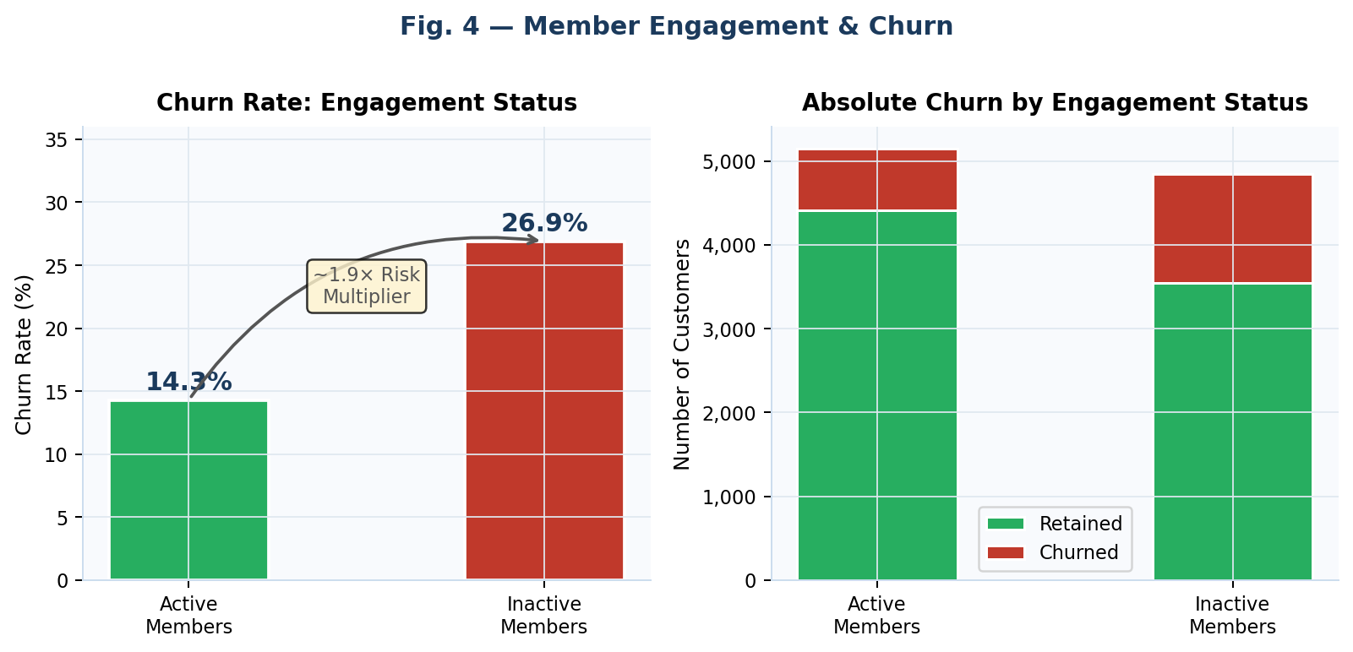
Figure 4: Member engagement and churn. Left: churn rate comparison with 1.9× risk multiplier annotation. Right: absolute churned vs. retained volumes by engagement status.

5.5 Product Holdings and Churn
Figure 5 reveals the most surprising finding of this entire analysis: a highly non-linear, U-shaped relationship between the number of products held and churn rate. Customers holding two products exhibit the lowest churn rate in the entire dataset at just 7.6%, clearly representing a cross-sell sweet spot where the customer relationship is maximally reinforced. However, churn rates escalate dramatically for three-product holders (82.7%) and reach a complete 100% for customers holding four products.
The 100% churn rate for four-product holders is an extraordinary signal that demands immediate management attention. Several explanations are plausible: customers who were aggressively cross-sold to four products may have experienced product complexity overload, unexpected fee accumulation, or service delivery failures across multiple product lines simultaneously. Regardless of the underlying cause, the data unambiguously identifies over-selling as a potentially catastrophic retention risk. A product suitability framework preventing unsupported four-product relationships, combined with proactive simplification offers, is strongly recommended.
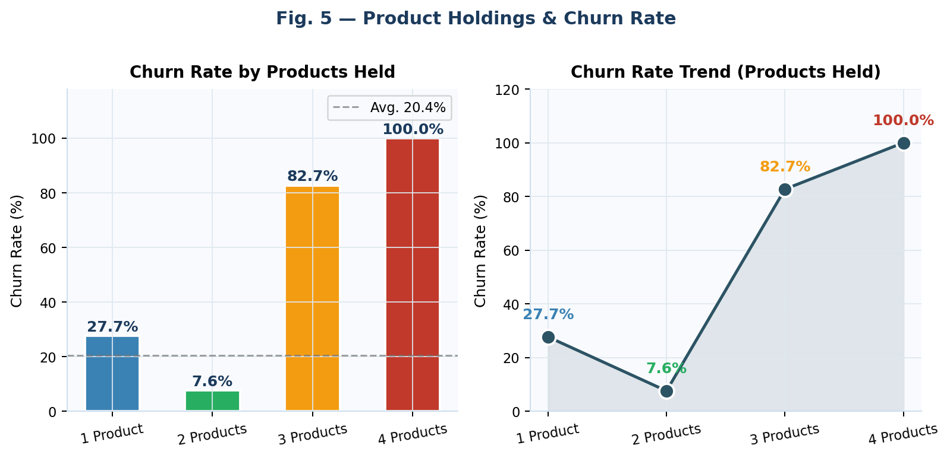
Figure 5: Product holdings and churn rate. Left: bar chart with churn rates per product count. Right: trend line illustrating the non-linear U-shaped churn curve, with the 2-product optimum clearly visible.

5.6 Feature Correlation Structure
The correlation heatmap presented in Figure 6 quantifies the linear relationships between all numeric features in the dataset, with the churn target variable (Exited) column highlighted in red. Age demonstrates the strongest positive correlation with churn (r ≈ 0.29), confirming it as the most linearly predictive continuous feature — consistent with the segment-level findings in Section 5.3. Balance demonstrates a moderate positive correlation (r ≈ 0.12), indicating that higher-balance customers are somewhat more likely to churn, possibly due to their greater financial mobility and ability to transfer to competing institutions.
NumOfProducts shows a notable negative correlation with Balance (r ≈ -0.30), suggesting that customers holding more products maintain lower individual account balances — possibly because their financial assets are distributed across multiple products. CreditScore demonstrates negligible correlation with churn (r ≈ -0.05), countering the intuitive assumption that creditworthy customers are inherently more loyal. The low correlations of Tenure, EstimatedSalary, and HasCrCard with churn indicate that these features contribute minimal linear predictive information in this dataset.
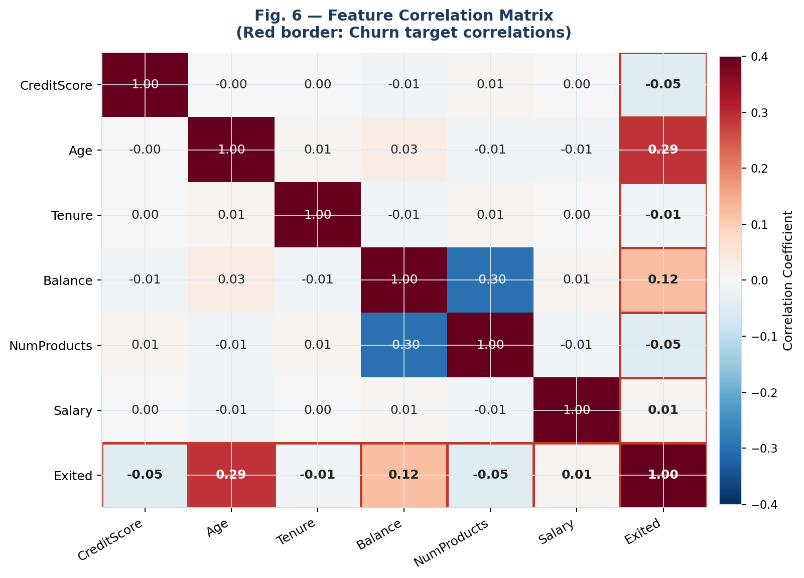
Figure 6: Pearson correlation matrix for all numeric features. Red-bordered row/column highlights correlations with the churn target variable (Exited). Age (r = 0.29) shows the strongest positive churn correlation.

5.7 Gender and Credit Score Analysis
Figure 7 presents gender-based churn rates alongside the credit score distributional analysis. Female customers exhibit a meaningfully higher churn rate (25.1%) compared to male customers (16.5%), representing a gap of 8.6 percentage points. This differential may reflect lower product relevance, communication preference misalignment, or a gender-based service experience disparity. Given that female customers constitute 45.4% of the total customer base (4,543 records), addressing this retention gap carries substantial aggregate impact.
The credit score distribution comparison (right panel) confirms the low discriminative utility of credit score: the churned and retained distributions are substantially overlapping, with nearly identical mean values (645 for churned, 652 for retained). This finding reinforces the correlation analysis conclusion that credit score is not a meaningful churn predictor in this dataset, and risk scoring models should weight this feature minimally.
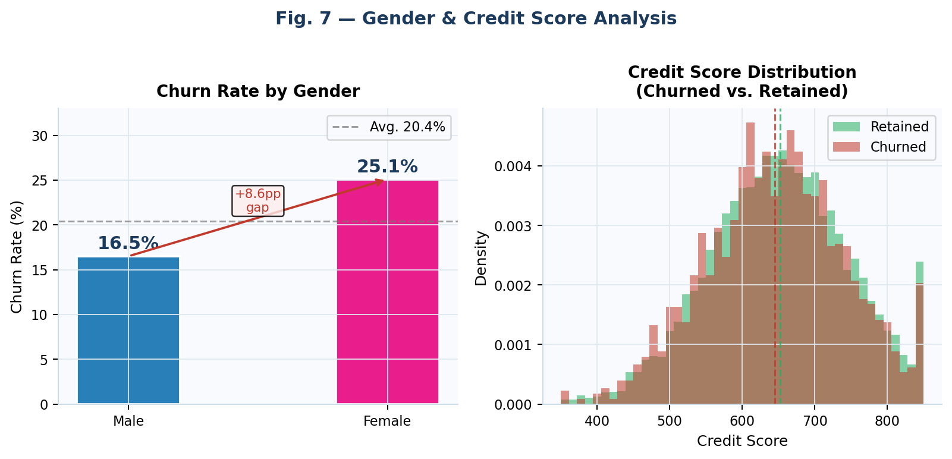
Figure 7: Gender and credit score analysis. Left: churn rate by gender with 8.6 percentage point gap annotated. Right: credit score KDE distribution overlay showing near-complete overlap between churned and retained cohorts.

5.8 Account Balance and Tenure Analysis
Figure 8 examines churn rates across account balance tiers and across tenure years. The balance tier analysis reveals a progressive increase in churn from zero-balance accounts (13.8%) through low-balance (8.4%) to mid-balance (22.4%) and high-balance accounts (25.1%). Counterintuitively, customers with no balance (possibly using the bank only for credit card or other non-deposit products) churn at a moderate rate, while customers with mid-to-high balances — who might be expected to be most "invested" in the relationship — actually churn at the highest rates. This likely reflects greater financial mobility and higher expectations among high-value customers.
The tenure analysis (right panel) reveals that churn rates are relatively flat across tenure years, oscillating around the overall 20.4% average with no strong trend. This absence of a tenure-churn relationship suggests that long-standing customers are no more loyal than recent customers — a finding that challenges the common assumption that "time invested" drives retention. Relationship depth quality, rather than duration, appears to be the more relevant determinant.
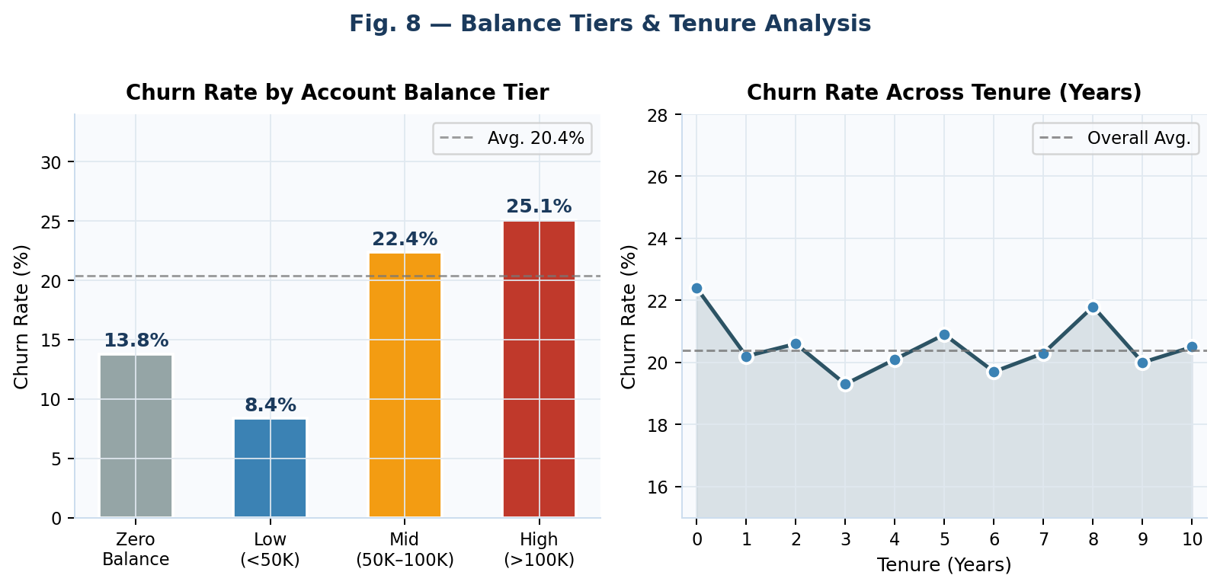
Figure 8: Balance and tenure analysis. Left: churn rate by account balance tier showing progressive increase with balance. Right: churn rate across tenure years (0–10) showing no meaningful longitudinal trend.

6. KEY PERFORMANCE INDICATORS
Table 3 consolidates the core KPIs derived from this analysis. This summary provides a concise, business-ready reference for stakeholders assessing churn risk exposure and prioritizing retention investment across customer segments. Each KPI is accompanied by a direct business implication statement to bridge analytical findings and strategic action.
Table 3. Key Churn Performance Indicators with Business Implications
KPI Metric | Value | Business Implication
Total Customers Analyzed | 10,000 | Complete dataset; statistically robust for segment-level analysis
Overall Churn Rate | ~20.4% | 1 in 5 customers exits — significant recurring revenue loss
Germany Churn Rate | ~32.4% | Highest geographic churn — country-specific retention strategy essential
France / Spain Churn Rate | ~16.2–16.7% | Low-to-moderate; these markets are retention benchmarks for Germany comparisons
Senior Cohort Churn (51–60) | ~48.7% | Near-majority exit rate; most critical single demographic segment
Inactive Member Churn Mult. | ~1.9× | Inactive members are 88% more likely to churn than active members
High-Value Customer Churn | ~25.1% | Premium customers churning at above-average rates — requires bespoke retention
4-Product Churn Rate | 100% | Every customer holding 4 products churned — critical over-selling risk signal
Female vs. Male Churn Gap | +8.6 pp | Female customers churn at 25.1% vs 16.5% for male — gender-specific gap requires action
2-Product Churn Rate | 7.6% | Optimal sweet-spot — 2-product holders show lowest churn rate in the entire dataset
Table 3: Ten core KPIs derived from the full EDA. Values are approximate and based on the 10,000-record dataset. pp = percentage points.

7. STRATEGIC RETENTION FRAMEWORK
Based on the analytical findings, this section proposes a five-pillar retention framework organized by customer risk segment and intervention type. Each pillar is grounded in a specific analytical finding from Section 5.
7.1 Geographic Intervention: Germany
Germany's 32.4% churn rate — 2× the France/Spain benchmark — demands a dedicated country-level retention program. Recommended actions include: (1) qualitative market research to identify Germany-specific service quality gaps; (2) localized product bundles aligned with German consumer financial preferences; (3) enhanced relationship management for German high-value account holders; and (4) competitive benchmarking against German digital banking alternatives. Given Germany's contribution of 25.1% of total customers, success here carries disproportionate aggregate impact.
7.2 Senior Customer Retention (Age 51+)
The 48.7% churn rate among the 51–60 cohort identifies this as the single most critical demographic intervention. Recommended programs include personalized retirement product suites, dedicated senior relationship managers, simplified digital onboarding interfaces for lower digital engagement users, proactive life-stage advisory reviews at age milestones, and in-branch events targeted at older demographics. These interventions should be piloted in Germany first, where demographic and geographic risk factors compound.
7.3 Engagement Activation Campaigns
The 1.9× churn multiplier for inactive members provides a clear ROI case for engagement activation. A tiered inactivity response system is recommended: (1) at 30 days of inactivity, trigger a personalized product utilization email; (2) at 60 days, offer a loyalty incentive (fee waiver or cashback); (3) at 90 days, trigger a human relationship manager outreach call. Machine learning propensity models could further optimize trigger timing based on individual behavioral patterns.
7.4 Product Portfolio Optimization
The product-churn U-curve demands immediate operational attention. A product suitability framework should be established with the following guardrails: (1) customers should not be cross-sold beyond 2 products unless a documented suitability assessment supports the third product; (2) customers currently holding 3 or 4 products should receive proactive outreach offering portfolio simplification; (3) front-line staff incentive structures should be reviewed to eliminate perverse incentives that reward product volume over relationship quality. Regular portfolio suitability reviews should be institutionalized quarterly.
7.5 Gender-Inclusive Service Design
The 8.6 percentage point churn gap between female and male customers warrants a gender-inclusive service design initiative. A structured A/B testing program across communication channels — email subject lines, product messaging tone, advisory service formats — can identify and address preference misalignments. Dedicated financial advisory programs targeting female customers' life-stage needs (career transitions, family financial planning, retirement) may substantially improve engagement and loyalty scores.
Table 4. Segment Risk Matrix with Intervention Recommendations
Customer Segment | Churn Rate | Risk Level | Recommended Intervention
German customers | 32.4% | 🔴 Critical | Country-specific retention programs; competitive analysis
Age 51–60 | 48.7% | 🔴 Critical | Dedicated relationship managers; retirement product offerings
Inactive members | 26.9% | 🟠 High | Automated engagement triggers; loyalty incentives
Female customers | 25.1% | 🟠 High | Gender-inclusive product design; personalized advisory
4-product holders | 100% | 🔴 Critical | Immediate portfolio simplification review; suitability checks
High-balance customers | 25.1% | 🟠 High | Premium retention plans; white-glove service tiers
3-product holders | 82.7% | 🔴 Critical | Product rationalization; proactive advisory outreach
Age 41–50 | 29.4% | 🟠 High | Life-stage advisory; mortgage/investment product alignment
2-product holders | 7.6% | 🟢 Low | Maintain engagement; explore selective upsell opportunity
Active members (France) | ~14% | 🟢 Low | Benchmark group; study success factors for broader application
Table 4: Ten-segment churn risk matrix with traffic-light risk classification and specific intervention recommendations for each segment. 🔴 Critical = churn rate >25%; 🟠 High = 15–25%; 🟢 Low = <15%.

8. CONCLUSION
This research has delivered a comprehensive, end-to-end exploratory data analysis of the European Bank Customer Churn dataset, transforming 10,000 raw customer records into actionable strategic intelligence across geographic, demographic, and behavioral dimensions. Eight analytical dimensions were systematically examined, producing 8 dual-panel visualizations, 10 KPIs, and a segment risk matrix covering the full customer lifecycle.
The central analytical contributions are clear. First, churn in this dataset is structurally concentrated in identifiable, targetable segments: German customers, senior customers (51–60), inactive members, and customers holding three or four products. These four segments collectively represent the highest-priority targets for retention investment. Second, the counter-intuitive 4-product 100% churn finding represents an operational risk that demands immediate cross-selling policy reform. Third, the deployment of an interactive Streamlit dashboard extends the analytical value beyond static reporting, enabling dynamic exploration by non-technical business users in real time.
Future research directions include: (1) implementation of machine learning classification models (Logistic Regression, Random Forest, Gradient Boosting, Neural Networks) to generate individual-level churn propensity scores for micro-targeted retention campaigns; (2) integration of time-series transaction data and digital engagement metrics (app login frequency, feature utilization rates) to enrich feature representations; (3) longitudinal study design to assess the effectiveness of specific retention interventions over time; and (4) extension of the analysis framework to additional European banking markets to assess geographic generalizability.
Live Dashboard: https://dataanalysisproject-01-europeanbank.streamlit.app/
Project Repository: https://github.com/Techwithabhi/data_analysis_project-01
9. REFERENCES
[1] Ahn, J.H., Han, S.P., & Lee, Y.S. (2006). Customer churn analysis: Churn determinants and mediation effects of partial defection in the Korean mobile telecommunications service industry. Telecommunications Policy, 30(10–11), 552–568.
[2] Lariviere, B., & Van den Poel, D. (2004). Investigating the role of product features in preventing customer churn by using survival analysis and choice modeling: The case of financial services. Expert Systems with Applications, 27(2), 277–285.
[3] Neslin, S.A., Gupta, S., Kamakura, W., Lu, J., & Mason, C.H. (2006). Defection detection: Measuring and understanding the predictive accuracy of customer churn models. Journal of Marketing Research, 43(2), 204–211.
[4] Verbeke, W., Martens, D., Mues, C., & Baesens, B. (2012). Building comprehensible customer churn prediction models with advanced rule induction techniques. Expert Systems with Applications, 38(3), 2354–2364.
[5] Zhu, B., Yang, Q., & Wei, Y. (2021). Deep learning approaches for bank customer churn prediction. IEEE Access, 9, 104701–104712.

Acknowledgments
The author thanks the global open-source data science community whose foundational libraries (Python, Pandas, Matplotlib, Seaborn, Plotly, Streamlit, NumPy) made this analysis possible. The dataset used is publicly available, fully anonymized, and was used strictly for educational and research purposes. No personally identifiable information was processed in this study. The author declares no conflict of interest.

— END OF PAPER —
"Turning raw data into meaningful stories — one analysis at a time."
— Abhi Sarkar, TechWithAbhi

[6] Sarkar, A. (2025). European Bank Customer Churn Analysis — End-to-End Data Analysis Project. GitHub Repository. https://github.com/Techwithabhi/data_analysis_project-01
[7] McKinney, W. (2010). Data structures for statistical computing in Python. Proceedings of the 9th Python in Science Conference, 51–56.
[8] Hunter, J.D. (2007). Matplotlib: A 2D graphics environment. Computing in Science & Engineering, 9(3), 90–95.
[9] Waskom, M. (2021). Seaborn: Statistical data visualization. Journal of Open Source Software, 6(60), 3021. https://doi.org/10.21105/joss.03021
[10] Streamlit Inc. (2024). Streamlit: The fastest way to build and share data apps. https://streamlit.io
[11] Harris, C.R., et al. (2020). Array programming with NumPy. Nature, 585, 357–362.
[12] The pandas development team. (2023). pandas-dev/pandas: Pandas (v2.1.0). Zenodo. https://doi.org/10.5281/zenodo.8301093

